Domain-Driven Design (DDD) — Explained
DDD is a software design approach introduced by Eric Evans in his book Domain-Driven Design: Tackling Complexity in the Heart of Software (2003).
It’s not just about code → it’s about aligning software with the business domain.

🌍 1. What is a Domain?
- A domain is the problem space your business operates in.
- Example (E-commerce): Ordering, Payments, Shipping, Inventory.
- Each domain has its rules, processes, and data.
👉 DDD says: instead of starting from databases or frameworks, start from the domain and business language.

📖 2. Key Concepts in DDD

🔹 Ubiquitous Language
- A common language shared by developers + business experts.
- Avoids tech jargon. Everyone uses the same terms.
- Example: Don’t say "processPaymentRecord()", say "ChargeCustomer()" if that’s the business term.

🔹 Bounded Context
- The boundary around a part of the domain where terms, rules, and models are consistent.
- Each bounded context = 1 microservice (usually).
- Example in e-commerce:
  - Order Context → manages orders.
  - Payment Context → handles payments.
  - Inventory Context → stock management.
👉 Different contexts can use the same words differently → and that’s OK. (e.g., “Customer” in Order vs Payment).

🔹 Entities
- An Entity is something that has a unique identity (ID) that runs through its lifecycle.
- Even if its attributes change, it’s still the same entity.
👉 Example (E-commerce Order):
- Order is an entity.
- It has OrderId (unique identity).
- If you update the shipping address, it’s still the same order.
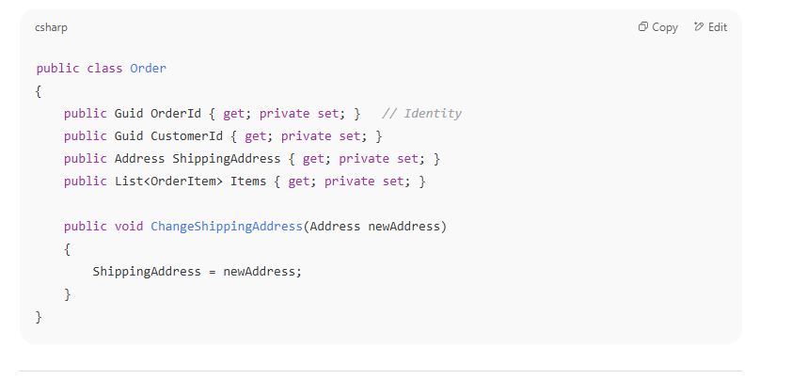

🔹 Value Objects
- A Value Object is identified only by its values, not identity.
- They are immutable → if something changes, you create a new one.
- They should be replaceable with another object having the same values.
👉 Example (Order Address & Money):
- Address (Street, City, Zip) is a value object.
- Money (Amount, Currency) is a value object.
- If two addresses have the same values, they are considered the same.

Another strong example: 📅 DateRange (Booking Period)
When you book a hotel:
- A stay from 1st Jan to 5th Jan is a fixed value.
- If you “change” it to 2nd Jan to 6th Jan → it’s not the same booking period.
- You throw away the old range and create a new DateRange object.
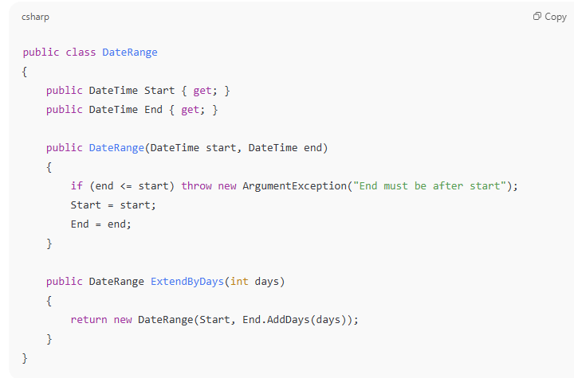

🔹 Aggregates
- An Aggregate is a cluster of Entities + Value Objects that belong together.
- Each Aggregate has a single Aggregate Root (main entity).
- Only the Aggregate Root is accessible from outside.
- Consistency rules apply inside an Aggregate.
👉 Example (Order Aggregate):
- Order = Aggregate Root
- OrderItems = Entities or Value Objects inside it.
- You can’t just add/remove OrderItems directly — you must go through Order methods → ensures rules are respected.
👉 Rules are enforced at the aggregate level.

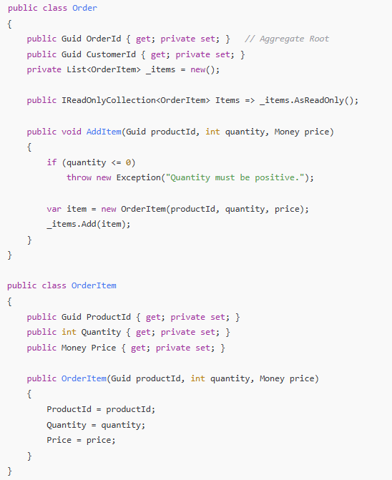

📦 Putting It All Together (E-commerce Example)
- Entities
  - Order (Aggregate Root, identity = OrderId)
  - Customer (identity = CustomerId)
  - Payment (identity = PaymentId)
- Value Objects
  - Address (Street, City, Zip)
  - Money (Amount, Currency)
  - OrderItem (ProductId, Quantity, Price)
- Aggregates
  - Order Aggregate → (Order root + OrderItems)
  - Customer Aggregate → (Customer root + Address VO)
  - Payment Aggregate → (Payment root + Money VO)

✅ Key Clarification
- Every Aggregate Root is also an Entity.
- But not every Entity is an Aggregate Root.
That’s why the class Order looked the same in Entities and Aggregates — it is both:
- It’s an Entity because it has an identity (OrderId).
- It’s also the Aggregate Root because it controls access to other objects (OrderItems, ShippingAddress).

✅ Rule in DDD
An Aggregate should not directly contain another Aggregate (entity).
Instead, it should reference it by identity (ID).
So:
- Customer is its own Aggregate Root (with its own lifecycle, rules, and database table).
- Order is another Aggregate Root.
- The Order should not embed the whole Customer entity.
- Instead, the Order holds the CustomerId (a reference).

🔹 Repositories
- Abstractions that give access to aggregates.
- Example: OrderRepository.Get(orderId) returns an Order aggregate.

🔹 Domain Events
- Something that happened in the business domain that others care about.
- Example: OrderPlaced, PaymentFailed.
- These events often trigger workflows in other bounded contexts (→ this is where SAGA comes in).

🔹 Factories
- Used to create complex aggregates.
- Example: OrderFactory.Create(customerId, items).

🧩 3. Layers in DDD
DDD suggests layering to separate concerns:
- Domain Layer → Entities, Value Objects, Aggregates, Domain Services, Events.
- Application Layer → Coordinates tasks, but doesn’t contain business logic.
- Infrastructure Layer → Database, external APIs, messaging.
- User Interface Layer → API endpoints, UI.
Domain Layer: Contains business rules and concepts (Entities, Value Objects, Domain Events, Repository Interfaces).
Application Layer: Contains use cases and application logic (Command/Query Handlers, Application Services). It depends on the Domain Layer.
Infrastructure Layer: Contains technical implementation details (Persistence, Email, APIs, Repository Implementations). It depends on the Domain and Application layers.

1. Domain Layer (Business Rules)
- Core business logic.
- Contains entities, value objects, domain services.
- Pure C#, no EF Core or ASP.NET stuff here.
- The Domain Layer is the innermost, most stable core and should have no dependencies on any outer layer.
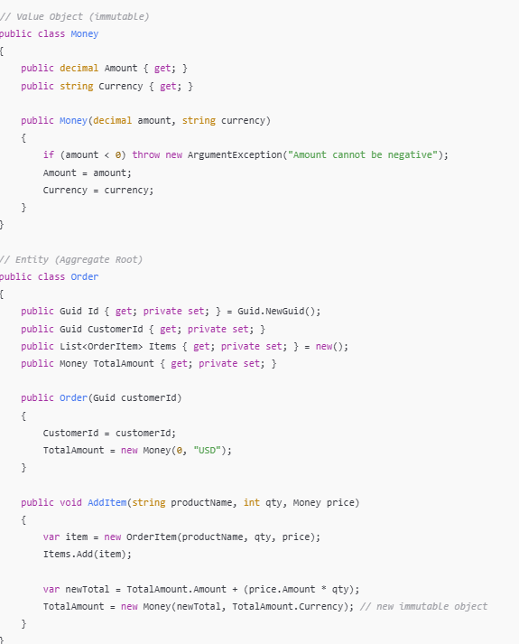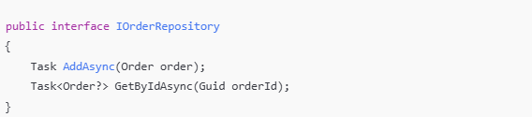

2. Application Layer (Use Cases)
- Coordinates between domain & infrastructure.
- Contains services that represent use cases.
- Calls repositories, but doesn’t know how data is stored.
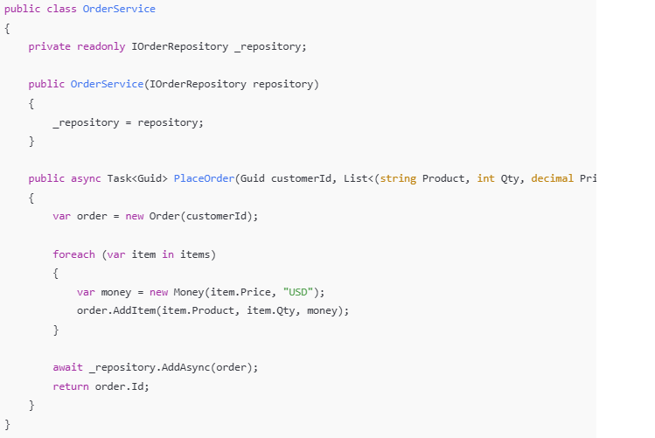

3. Infrastructure Layer (Data + External Systems)
- Implements repositories, persistence, external APIs.

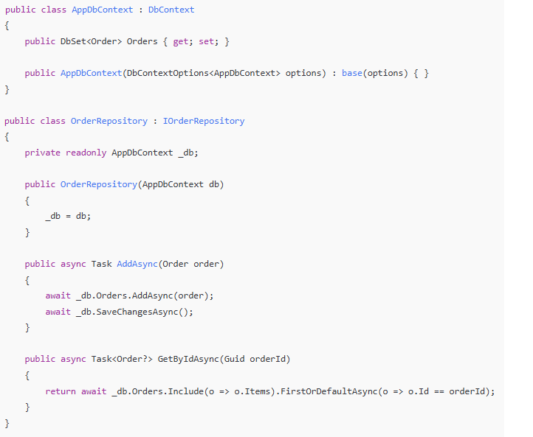
4. Presentation Layer (API)
- Exposes endpoints.
- Calls Application Layer services.
- Thin controller, no business logic inside.
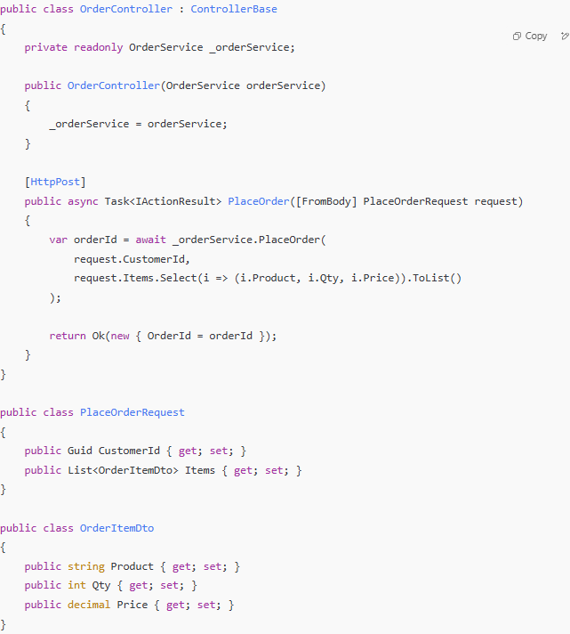
Differences between Entities and Data Transfer Objects (DTOs) in software design?
1. Entities
- Definition: An entity represents a real-world object or concept within your application's domain, like a "Customer," "Product," or "Order".
- Purpose: Entities are the core building blocks of your domain model, capturing business logic, relationships, and behavior associated with the domain object.

2. Data Transfer Objects (DTOs)
- Definition: A DTO is a simple, lightweight object used to transfer data between different layers or components of an application.
- Purpose: DTOs encapsulate data for specific use cases, separating data transfer concerns from business logic and ensuring controlled data exposure.
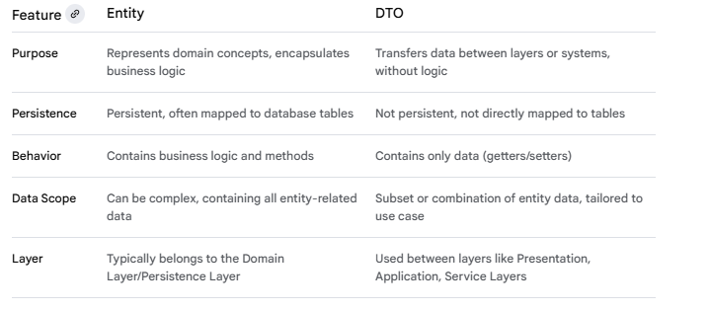
Typically, DTOs are associated with the
- Application Layer: This layer typically defines and uses DTOs for input and output parameters of application services. These DTOs encapsulate data needed for specific use cases, abstracting away the underlying domain entities.
- Presentation Layer: DTOs can also be used in the presentation layer to represent data tailored specifically for the user interface. These may be derived from DTOs or domain objects passed from the application layer.
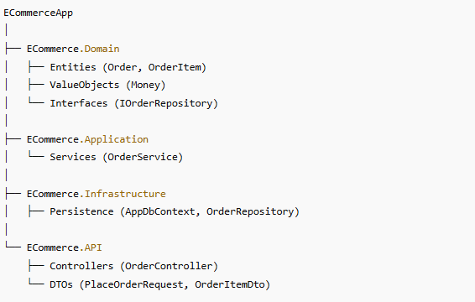

🏪 4. Example — E-commerce Order Flow
- Order Context
  - Entity: Order
  - Value Object: OrderItem (productId, qty, price)
  - Aggregate Root: Order (with rules like “total must be > 0”)
  - Domain Events: OrderPlaced
- Payment Context
  - Entity: Payment
  - Value Object: Money
  - Domain Events: PaymentSucceeded, PaymentFailed
- Inventory Context
  - Entity: ProductStock
  - Domain Events: StockReserved, StockReleased
👉 Each is a bounded context → implemented as separate microservices.
👉 They talk via domain events (message broker).

⚖️ 5. Benefits of DDD
- Aligns software design with business language.
- Makes large systems more manageable (bounded contexts).
- Improves communication between devs and domain experts.
- Provides a blueprint for microservice boundaries.

⚠️ 6. Challenges of DDD
- It’s complex → not needed for small/simple apps.
- Requires deep domain knowledge (collaboration with business experts).
- Implementation can be time-consuming (lots of modeling).

🚀 7. DDD + Microservices
- Each bounded context → 1 microservice.
- Each service has its own database.
- Services communicate via domain events.
- Aggregates ensure local consistency, while eventual consistency happens across services.

✅ In short:
DDD = “Model your software around the business, not the database or tech stack.”
It gives you the theory & patterns to design clean, business-focused microservices.

